SLK Brabus V 1.0.

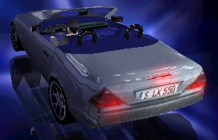
I'm back again with another brilliant Mercedes. Now it's not a Mercedes-Benz, but another cool car. My Brabus SLK represents the convertible version of my SLK, but with a little bit MORE POWER. Drive the car, love it and tell me, if really you can live without it. I don't think so.
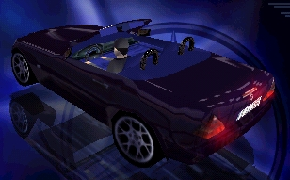

Installation:
Unzip the car.viv file into a subdirectory called "SLKB" in your NFS3/gamedata/carmodel folder.

Used tools:
- VIV Wizard V.07
- CarCAD (4)
- Corel Photopaint 7.0

This car is based on my SLK. It has a little MORE POWER, a new dashboard, bigger wheels, different textures and a new 3D mesh. It also has a better performance and brakes (if you girlish guys out there need that...).
But the car is more difficult to handle than some other even-my-mommy-is-able-to-beat-your-best-time-on-Hometown-with-that-car car. So it won’t be so boring to drive. Please don’t copy my work, update the car if you want, but DON’T COPY IT! I HATE THAT!

Special thanks to:
Thomas: Your stuff is a great job again. This guy is great!! Thanks for your help!
Ivan for the pictures,
Jkay for the rims,
the authors of VIV-Wizard and CarCAD,
me, because I am that good!

Creditz:
This program and all files within the SLK Brabus.zip are copyright 1999 by the author, Felixx, scale@wtal.de . You do not have permission to put it on any CD-ROM or other media (including magazine cover cd´s, and compilations) that is to be retailed without the authors prior written conscent.
The file itself, SLK Brabus.zip in its ORIGINAL STATE, may be distributed at no cost to anyone!
Please feel free to send it to your friends.
You can use it as a base for your work, but you have to credit me for this and notify me before you release it.
If you put this SLK Brabus.zip on your homepage for download, be so kind and inform me. In this case I am able to send you coming updates and new files.

"Mercedes, Mercedes-Benz, SLK" and all other trademarks are Copyright of DaimlerChrysler AG.
"Brabus" is a trademark of Brabus A.G.

Electronic Arts is Copyright 1998
All Need For Speed Titles are Copyright of Electronic Arts
Need For Speed 3 is Copyright of Electronic Arts 1998

Annotations? Trouble? Send me an e-mail: scale@wtal.de

